IDEAS Pre U-Motion
12-15 Year Old Summer Camp
To achieve more possibilities in Adolescence at UWC Changshu!
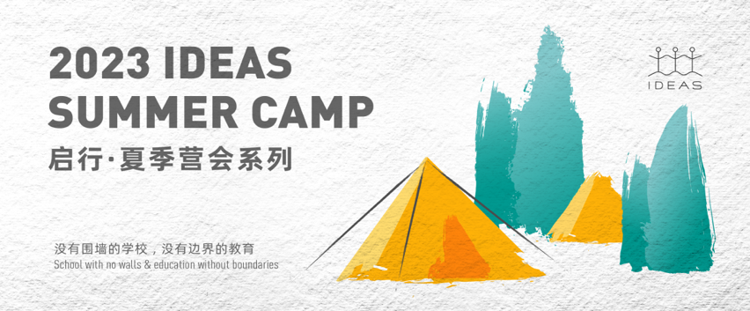
IDEAS Pre U-Motion 2023 is a 12-day comprehensive camp focusing on camp education. Campers aged 12-14 from all over the world will gain different perspectives and skills through learning in new fields, and find out who they are to become a better self.

Due to some prejudices brought about by traditional cultural stereotypes, some people think that teenagers are often associated with negative traits such as "impulsive","rebellious" and "inexplicable", and what parents can do is to endure and correct. In fact, adolescence is also a period of strong plasticity and creativity for them.

According to outstanding psychologists and scientists of various centuries, the brain of teenagers is in an important stage of reorganization. If teenagers often experience novel and challenging things and participate in cognitive stimulation activities, they can maintain the plasticity of the brain.

In this way, they will have sufficient time to choose their future careers and explore their own identities, instead of making premature decisions that will affect their future lives. IDEAS Pre U-Motion 2023 teamed up with excellent teachers at home and abroad to create a world class education for pre-adolescent children aged 12-15. It will take 12 days for children to work with outstanding peers to broaden their horizons and reshape cognition, calm restlessness, and reach extraordinary achievements.
01. HIGHLIGHTS
Camp Highlights and Skill Development

Pre U-Motion is committed to helping campers solve personal, emotional, academic, and social challenges that they face during adolescence. Through the main sections such as "International Education Academic Capstone Course", "Generalized Design Workshop" and "SEL Themed Activities", we will lead campers through experiential and project-based learning journeys to cultivate "PBL" self-driving ability and "SEL" social-emotional core ability.

The camp will provide effective "solutions" for the "troubles" of adolescent campers, and ultimately hope that adolescents can maturely establish positive and positive links with themselves, other individuals and the world.

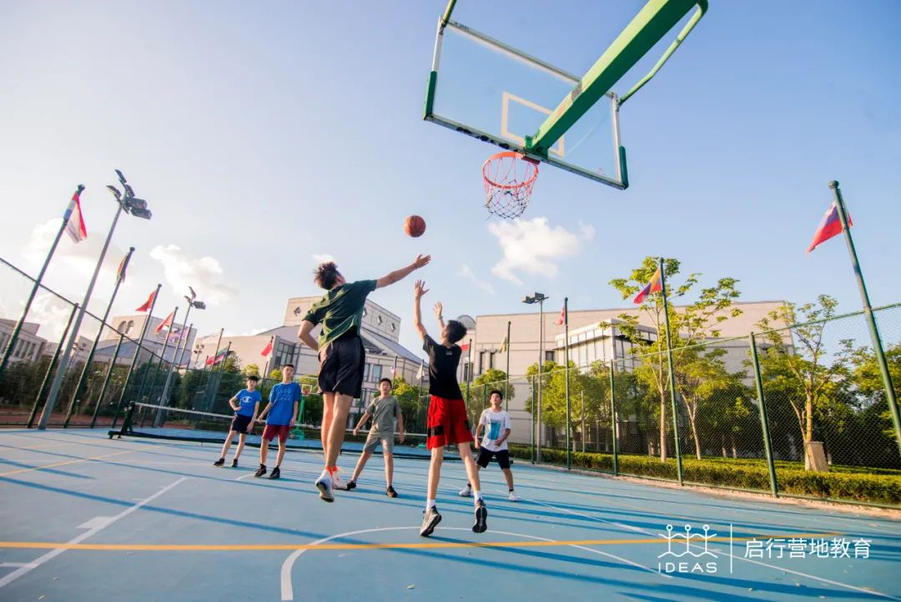

A. The concept of Design Thinking
"Uncovering the Underlying Logic of Problem Solving"

During adolescence, children begin to pay attention to the real world, from complex international issues such as epidemics and wars to the immediate pressure of academic advancement, all waiting for them to solve. The ability to solve problems requires practice. Design Thinking, which is advocated by Apple and Google, provides a "one-size-fits-all" problem-solving methodology.

Pre U-Motion 2023, teaming up with senior designers in the industry, offers a broad-based design workshop based on this concept. Through PBL project-based learning, campers will learn to master the design concepts and thinking modes of the world's leading technology companies in actual design projects, cultivating children's ability to solve complex problems.

B. SEL experiential learning throughout the camp
"Becoming emotionally stable and self-consistent adolescents"

The development of the body, changes in cognition, and personality growth put teenagers in an emotionally unstable stage, urgently requiring emotional guidance and social emotional learning (SEL) to cope. SEL is recognized as one of the best ways to improve self-management skills.

In 2023, Pre U-Motion will join forces with professional psychological counselors to design SEL workshops that run throughout the camp, targeting common issues that teenagers face such as academic stress, campus romance, and parent-child relationships.

Through experiential activities such as painting therapy, drama expression, interesting lectures, group discussions, and debates, campers will gain emotional management skills and enhance their self-efficacy in a safe environment with their peers.

C. Role Modelling and support of counselors throughout camp
"Helping to solve life's puzzles through the experience of predecessors"

For adolescents, the voices of role models sometimes have more influence than parental guidance.
In 2023 Pre U-Motion, we will invite several outstanding UWC graduates to share their valuable experiences in academic and life choices through "pure practical" presentations and "leading by example," inspiring campers to pursue their own dreams.

In addition, the camp will be accompanied by top 50 college student mentors from both domestic and overseas, who will actively guide and lead the campers with the professional support of psychological experts, providing emotional guidance and promoting positive and active social interactions.

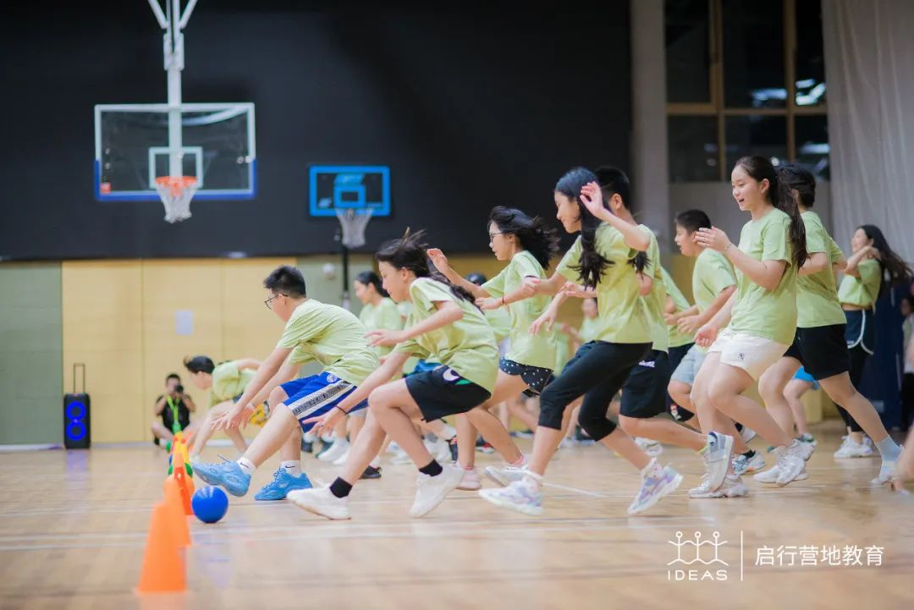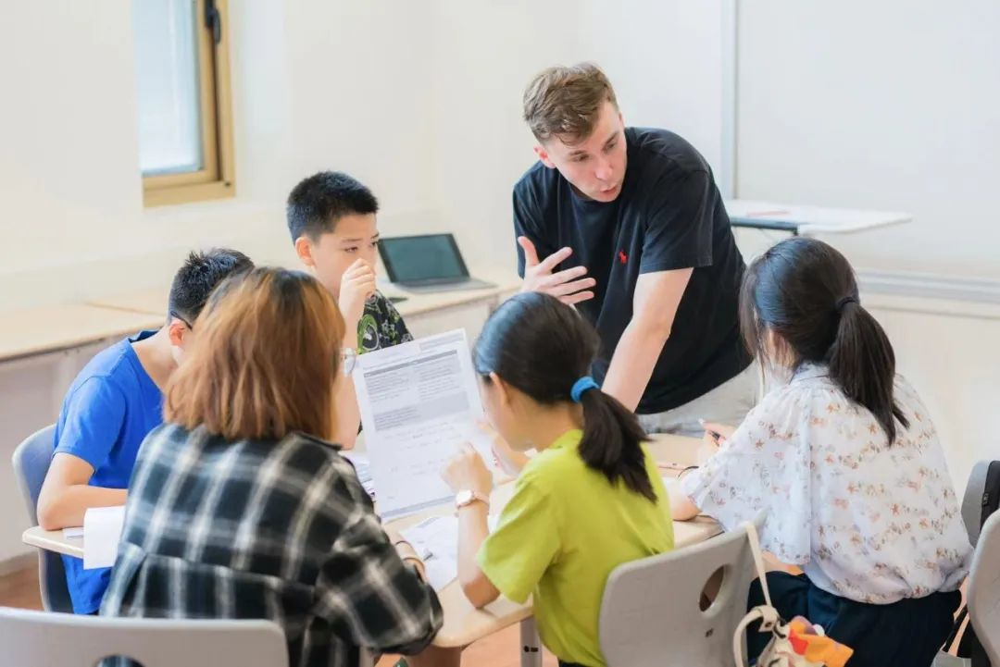

- WORKSHOPS
Multisensory experiential workshops

Swiss psychologist Jean Piaget's "cognitive development stage theory" points out that adolescents are entering the "formal operational stage" of rapid abstract thinking.

Adolescents undergo a qualitative leap in their perspectives on issues and develop a willingness to solve problems. They try to use abstract formulas in textbooks to explain specific phenomena.

Based on these changes, the 2023 IDEAS Pre U-Motion provides a combination of "Broad Design Workshops," "SEL Experiential Workshops," and "Physical Fitness Challenge Workshops," using PBL project-based learning methods to empower youth by mastering various thinking tools through multisensory practice in multiple scenarios.

- Design Workshops
The Design Workshops will subvert the shackles of traditional classroom teaching. There will no longer be teachers and students, but instead, project consultants and designers. The three optional directions of "Fashion Art Design", "Environmental Architecture Design", and "Innovative Product Design" fully leverage the autonomy of campers. Meanwhile, under the guidance of project consultants, they will use design thinking to transform their abstract ideas into tangible works, expand their perspectives on problem-solving, and enhance their ability to solve complex problems.

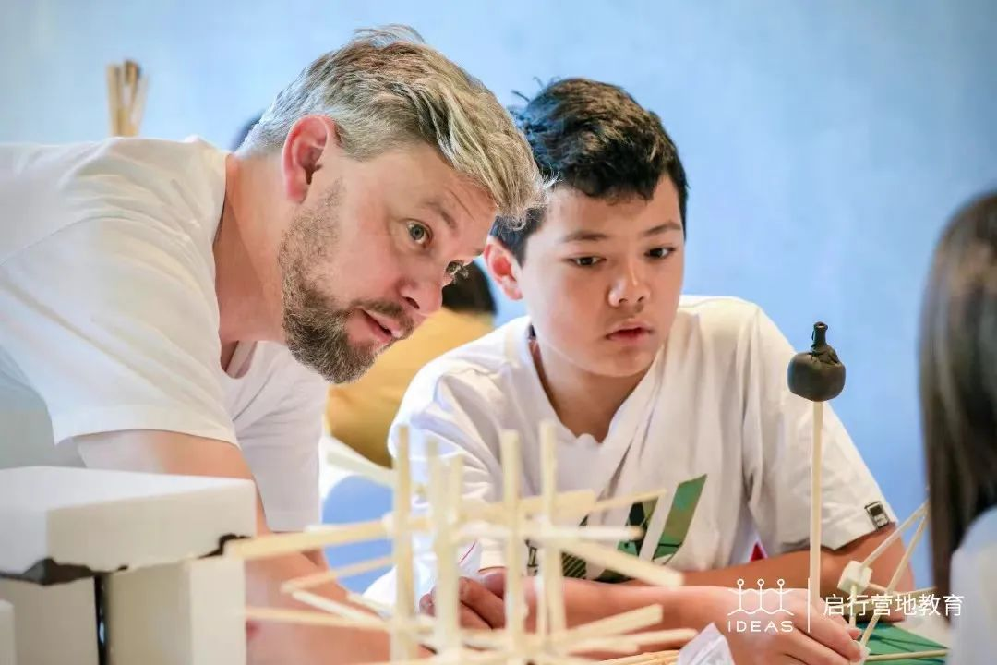

01 Fashion Art Design
In the Fashion Art Design workshop, campers will first-handedly experience the complete process of fashion illustration and sketching – apparel design – jewelry craft design – textile, fabric, colour and jewellry collocation – use of machinery for outfit production – a final catwalk show, to enjoy fashion designing, unleash their enthusiasm for creation, simultaneously entitling them with more abundant aesthetic creativity, artistic expression and critical thinking, allowing them redefine shape and fashion for themselves.

Campers shall delve deeply into the linkage between the concepts of fashion and the human body, showcasing their perception of "beauty" from the perspective of fashion designers, and design and produce their own fashion products.

02 Environmental Architecture Design
Under guidance of professional architects, campers will learn about architecture and the environment, and experience the complete process from “design frame and idea conception – architectural sketching – sand table model-making – product release”. During the process, campers learn to see the world and solve problems form the perspective of architectures, having to redefine the relationship between man and nature, architecture and society, to create buildings and an environment with warmth, sustainability, aesthetics and significance.

Through investigation and research “individuals and the environment”, campers will analyze the role of architectural design in regulating and relieving one’s emotions and feelings from different perspectives, and under the guidance of the workshop leader, complete the sand-table model of the “dream future school" in their minds.

03 Innovative Product Design
In the Innovative Product Design workshop, campers will experience the
process a new, innovative, every-day product has to go through before it is released in the public market. The design process and concepts range from “idea conception – artistic sketching and CAD drawing – use of production design technologies such as laser cutting, 3D printing etc – product release”. The process allows campers to delve into the most creative, personal, abstract or even odd product ideas of their own, while getting to know themselves once again from another dimension.

Under the leadership of the workshop leader, campers will practice comprehensive and multidimensional design thinking from the perspective of product designers, and transform the abstract ideas and concepts in their minds into a concrete design product.
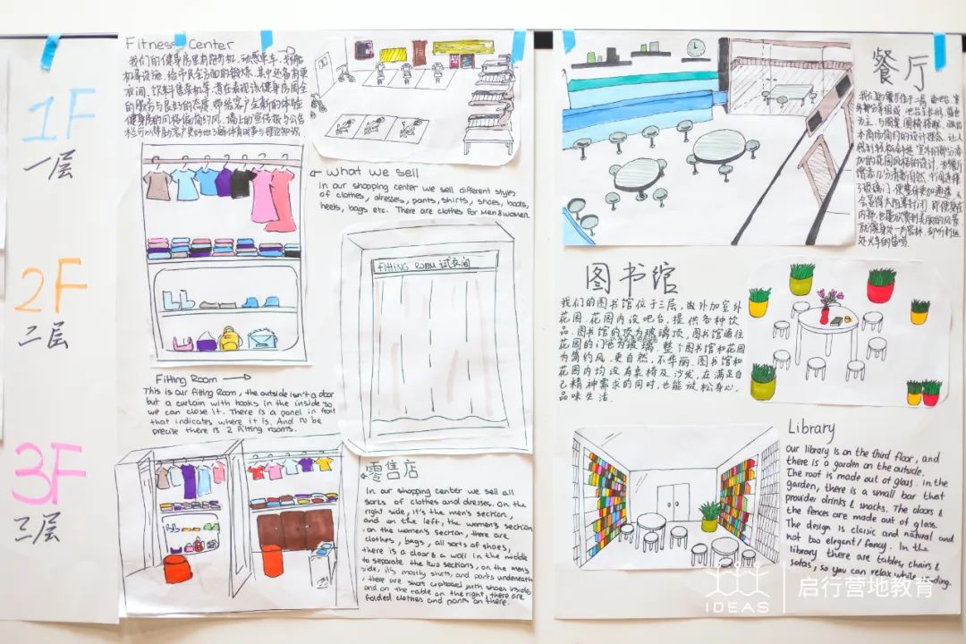
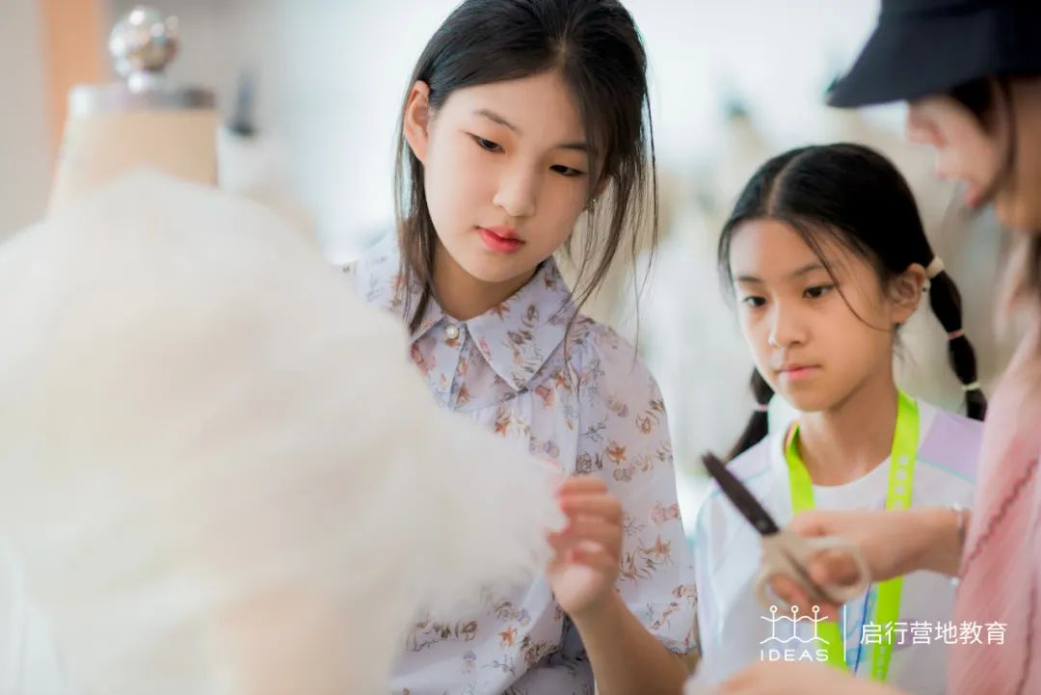
- SEL Experimental Learning Workshop
The SEL Workshop is a hands-on experience designed to help teenagers navigate the challenges of adolescence. Based on the developmental characteristics of young people, the workshop uses a step-by-step approach to social-emotional learning, connecting individuals to themselves, others, and society.

Led by professional counselors and psychologists, the workshop features fun activities and real-life scenarios designed to help campers develop emotional management and social skills while making new friends. Through the workshop, campers will gain a deeper understanding of themselves and their emotions, learn effective communication strategies, and develop positive relationships with others.

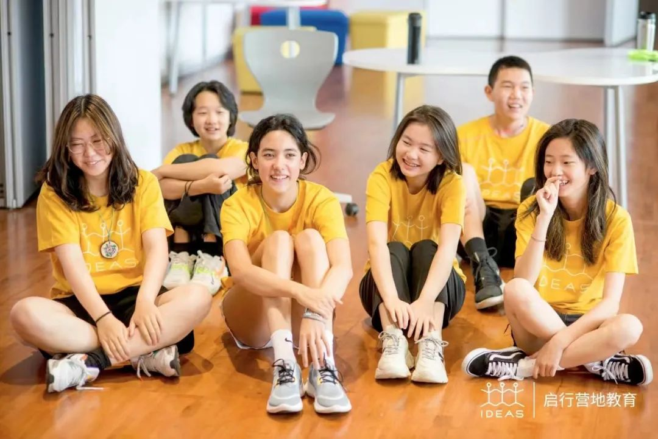

Stage 1.
Self-awareness
“Managing oneself starts with self-awareness”

Before understanding the world and connecting with others, we first need to understand ourselves, and drawing is an effective tool for self-awareness. As the saying goes, "I draw my heart with my pen," and everyone can unconsciously reveal their personal emotions and feelings through their creations.

In this stage, campers will express their feelings about joining the camp through drawing, and use color, composition, and style to explore their own self-awareness. By showcasing their artwork, they will also learn about their peers' different personalities and better connect with others.

Stage 2.
Emotional Awareness and Management
"Be the master of your own emotions"

After self-awareness, how can we manage ourselves?
And how can we deal with temper and negative energy when they arise?

The camp will invite professional psychologists to conduct a "Emotional Color Palette: Adolescent Emotional Brain Seminar" with campers to explore the secrets behind emotions from a neuroscience perspective. They will learn small tricks to manage emotions and become the master of their own emotions.

Stage 3.
Empathy and Understanding
"Breaking down interpersonal barriers through sharing and listening"

Who do you talk to about the pressures of growing up, first love, addiction to video games, and idol worship? "Youth 101 Coffee House" is a "tree hole" where campers can talk freely.
In the one-on-one Speed Dating mode and with the support of professional counselors, campers can release inner pressure through sharing and see different perspectives through listening, learn to accept differences, and empathize with others.

Stage 4.
Building and Maintaining Positive Relationships
"Using Positive Social Interaction to Explore a Broader World"

At the end of the journey, campers will use drama and debate to initiate positive social interaction, putting the learned SEL methodology into practice and experiencing the beauty of positive social interaction.

In the "My Friends and I" drama workshop, campers will use the power of language and body language through role-playing to learn how to build and maintain positive relationships.

The truth becomes clearer through debate. In the "Group Debate Competition," campers will debate popular topics of adolescence such as personal planning, love, and responsibility. They will collect evidence, work collaboratively, and engage in intelligent exchange of ideas, refining their thoughts.

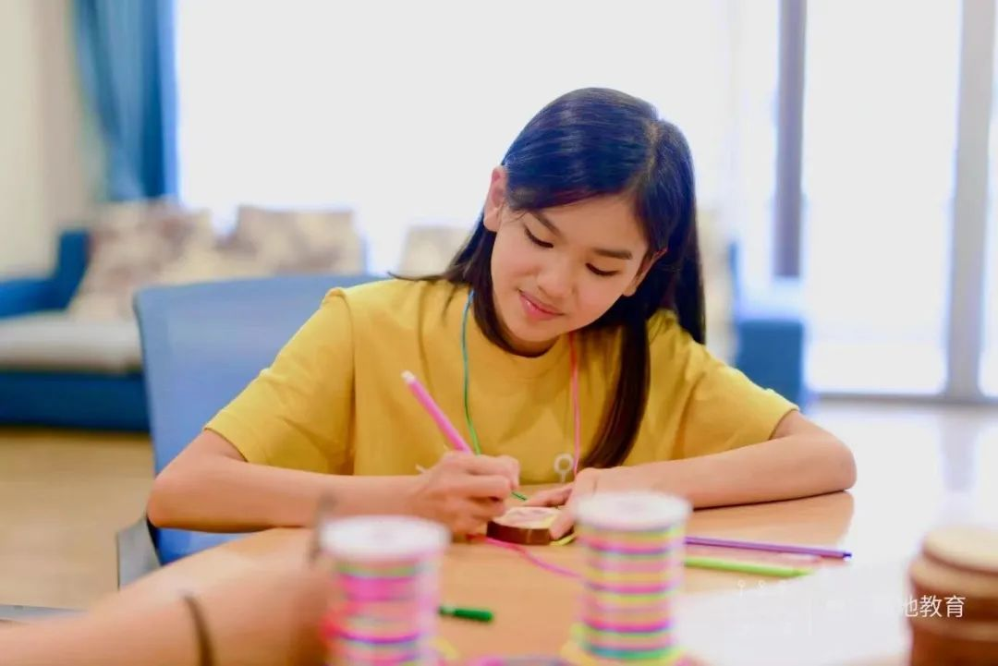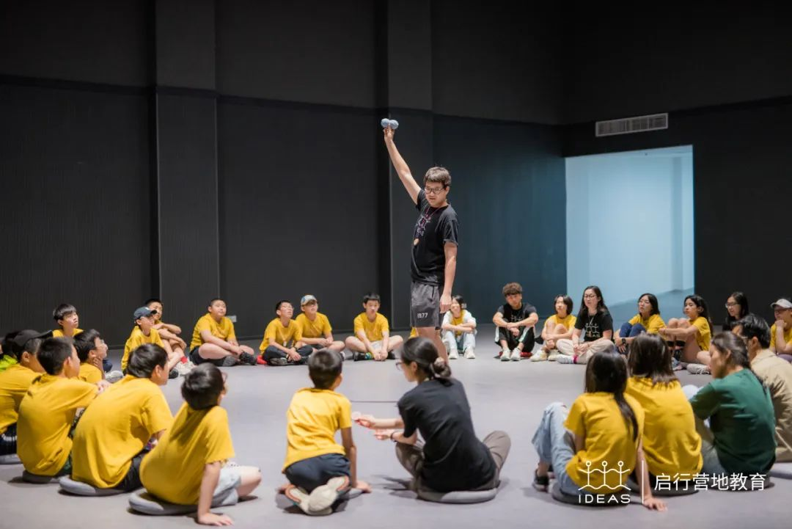

- Physical Challenge Workshop
Research has shown that aerobic exercise can help improve memory and learning performance, as well as reduce stress and improve mood in children.

During the one and a half hours of daily exercise time, campers can not only experience individual challenge projects such as rock climbing and sailing, which are exciting and unique to UWC, but also participate in team sports such as volleyball, basketball, field hockey, and lacrosse.

By exerting themselves on the sports field, campers can release their energy, develop social skills, connect with their teams, and gain a sense of accomplishment unique to competitive sports.
- ACTIVITIES
Diverse interactive whole camp activities

With the right balance of relaxation and excitement, the evening hours are dedicated to camp activities that complement and supplement the workshop learnings, enabling children to use social-emotional learning (SEL) skills across different scenarios in a relaxed atmosphere.

From self-awareness to self-challenge, from making peers to connecting with the entire camp community, everyone contributes their unique energy to create a positive camp environment while gaining the strength of partners and role models.

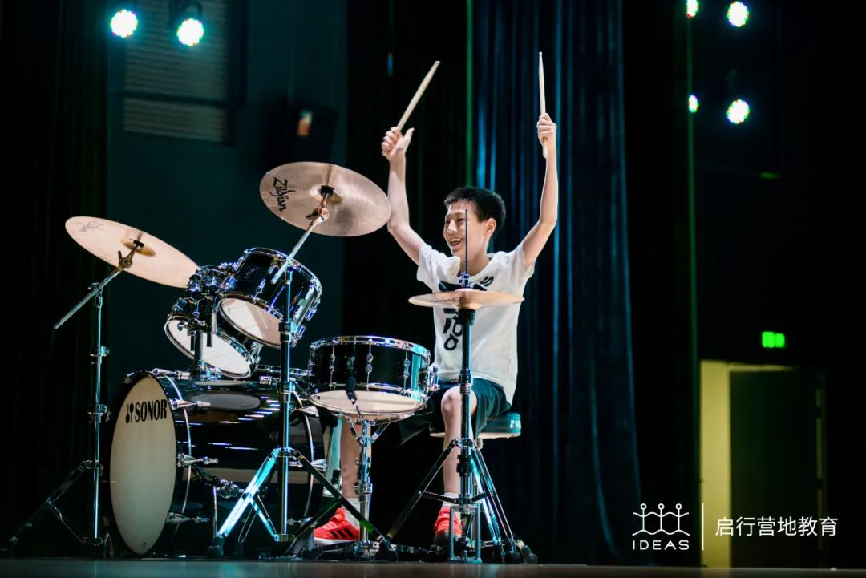

「College Forum Night」「 Who's the culprit?」
"Self-awareness, connecting with others"

At "College Forum Night," we invite UWC senior educational consultants, as well as alumni from famous schools at home and abroad, to discuss the matters of college admissions and personal growth with the campers, helping them set goals and manage their future.

In "Who's the culprit?" campers play detectives and gather clues and evidence in randomly assigned groups. While solving a murder case, they unlock knowledge of neuroscience and develop the ability to process information and communicate effectively as a team.

「Life Museum」「Under the Stellaris」
"Self-expression, living in the present"

In "Life Museum," campers look to the future and create their own life museums through artistic creation, displaying, sharing, and discussing their diverse selves and multidimensional life goals.

In "Under the Stellaris," campers have intimate conversations with young mentors, sharing their camp experience and life troubles, releasing themselves, and listening to growth advice.

「World Trade Simulation」 「Camp Olympics」「Camp Jeopardy」
"Self-challenge, teamwork"

On our "Special Day", campers temporarily put aside the task of designing workshops and enjoy classic camp activities that challenge themselves, such as "World Trade Simulation" and "Camp Jeopardy."

In "Camp Olympics," campers compete in athletic events and inspire a spirit of striving and cooperation, learning to manage and control their emotions and behaviors.
In "World Trade Simulation," they focus on current and complex global issues, stimulating their spirit of exploration and responsibility.
In "Camp Jeopardy," campers have ample opportunities to showcase their knowledge while feeling the charm of team cooperation.

